

Year 11 Unit 1 Examination, 2018

Question/Answer Booklet

CHEMISTRY

Student Name: ______________________________________________

Teacher Name: ______________________________________________

Time allowed for this paper
Reading time before commencing work: ten minutes
Working time for paper: two and a half hours

Materials required/recommended for this paper

To be provided by the supervisor
This Question/Answer Booklet
Multiple-choice Answer Sheet
Chemistry Data Sheet

To be provided by the candidate
Standard items: pens (blue/black preferred), pencils (including coloured), sharpener, correction tape/fluid, eraser, ruler, highlighters
Special items: up to three non-programmable calculators approved for use in the ATAR examinations

Important note to candidates
No other items may be taken into the examination room. It is your responsibility to ensure that you do not have any unauthorised notes or other items of a non-personal nature in the examination room. If you have any unauthorised material with you, hand it to the supervisor before reading any further.
Structure of this paper

Section | Number of questions available | Number of questions to be answered | Suggested working time  (minutes) | Marks available | Percentage of examination
Section One:  Multiple-choice | 20 | 20 | 40 | 40 | 25.0 %
Section Two:  Short answer | 8 | 8 | 50 | 58 | 36.25 %
Section Three:  Extended answer | 6 | 6 | 60 | 62 | 38.75 %
Total |  |  |  |  | 100.0 %

Instructions to candidates

1. Answer the questions according to the following instructions.

Section One: Answer all questions on the separate Multiple-choice Answer Sheet provided. For each question shade the box to indicate your answer. Use only a blue or black pen to shade the boxes. If you make a mistake, place a cross through that square, do not erase or use correction fluid, and shade your new answer. Marks will not be deducted for incorrect answers. No marks will be given if more than one answer is completed for any question.

Sections Two and Three: Write answers in this Question/Answer Booklet.

3. When calculating numerical answers, show your working or reasoning clearly. Express numerical answers to the appropriate number of significant figures and include appropriate units where applicable

4. You must be careful to confine your responses to the specific questions asked and to follow any instructions that are specific to a particular question.

5. Spare pages are included at the end of this booklet. They can be used for planning your responses and/or as additional space if required to continue an answer.
• Planning: If you use the spare pages for planning, indicate this clearly at the top of the page.
• Continuing an answer: If you need to use the space to continue an answer, indicate in the original answer space where the answer is continued, i.e. give the page number. Fill in the number of the question that you are continuing to answer at the top of the page.
Section One: Multiple-choice 25% (40 Marks)

This section has 20 questions. Answer all questions on the separate Multiple-choice Answer Sheet provided. For each question shade the box to indicate your answer. Use only a blue or black pen to shade the boxes. If you make a mistake, place a cross through that square, do not erase or use correction fluid, and shade your new answer. Marks will not be deducted for incorrect answers. No marks will be given if more than one answer is completed for any question.

Suggested working time: 40 minutes.

1. Which of the following are homogeneous mixtures?

i sodium chloride
ii. white vinegar
iii. white wine
iv. baked beans

- i and iii only
- ii and iii only
- iii and iv only
- ii, iii and iv only

2. A covalent bond would be expected to form between atoms which have the electron configurations

- 2,7 and 2,6.
- 2,8,8 and 2.
- 2,8,1 and 2,8,7.
- 2,8,5 and 2,8,8,1.
3. Which one of the following descriptions relates correctly to an ionic solid?

(a) an ordered lattice arrangement of cations and free valence electrons
(b) a crystalline form that is hard and has lustre
(c) a high melting point due to strong electrostatic interaction
(d) valence electrons are free to conduct charge

4. Which one of the following compounds contains only ionic bonds?

(a) CH₃COOH
(b) HCl
(c) NaH
(d) NaNO₃

5. Which one of the following statements best describes a covalent bond?

- The atoms have a noble gas configuration.
- The atoms have formed an infinite network.
- One of the atoms involved in the bond is a metal and the other is a non-metal.
- There is simultaneous attraction of both nuclei to a shared electron pair.

6. Which one of the following characteristics does not apply to solutions?

- They are homogeneous mixtures.
- They contain two or more substances.
- They have uniform composition.
- They always contain a solid that has dissolved in a liquid

7. Which one of the following statements about elements in Groups 1 and 2 on the Periodic Table is correct?

- They can only become positively charged and form strong covalent molecules.
- They form negative ions because they have few valence electrons.
- They can share electrons to form positive ions.
- They can form positive ions because they have loosely held valence electrons.

8. Use the table to identify a pair of isotopes.

Element | No. of Protons | No. of Electrons | No. of Neutrons
W | 20 | 21 | 21
X | 19 | 18 | 19
Y | 19 | 21 | 19
Z | 20 | 19 | 20

- Elements X and W
- Elements X and Y
- Elements W and Z
- Elements Y and W

9. Which one of the following correctly classifies the substances listed?

 | Covalent molecular | Ionic | Covalent Network | Metallic
(a) | C₆H₁₂O₆ | KBr | SiC | Mg
(b) | KNO₃ | CaCO₃ | CO₂ | Brass
(c) | CO₂ | NH₄Cℓ | Cℓ₂ | Ca
(d) | NH₄Cℓ | NaCℓ | C | Fe

10. Which one of the following statements about nanomaterials is false?

(a) Nanomaterials are substances that contain particles with specific properties which may differ from those of the equivalent bulk material.
(b) Nanomaterials are materials made of nano-particles which range from 1 – 100 nm in size.
(c) Fullerene, an allotrope of carbon, can be used to make nanomaterials.
(d) Nanomaterials are substances that contain only particles of 1 nm in size.

11. Which one of the following is the correct formula for magnesium phosphate?

(a) MgPO₄
(b) Mg₃(PO)₄
(c) Mg₂PO₂
(d) Mg₃(PO₄)₂

12. Which of the following is the electronic configuration for the Phosphide Ion, P³⁻?

(a) 1s² 2s² 3s⁶ 2p² 3p⁶
(b) 1s² 2s² 2p⁶ 3s² 3p⁴
(c) 1s² 2s² 2p⁶ 3s² 3p²
(d) 1s² 2s² 2p⁶ 3s² 3p⁶

13. Which one of following is the best explanation as to why ionic substances conduct electricity in both the molten and aqueous form?

- Ionic bonding is similar to metallic bonding in that when molten and aqueous they both have freely moving electrons.
- In both the molten and aqueous solution ionic substances have mobile ions.
- In both the molten and aqueous solution ionic substances have mobile electrons
- Ionic substances have high melting points and are brittle.
14. Separating pure water from sea water can be done simply by:

(a) evaporation.
(b) distillation.
(c) decantation.
(d) filtration.

15. Which two of these species represent an element, and its positive ion?

Species | Number of protons | Number of electrons | Number of neutrons
1 | 37 | 37 | 38
2 | 38 | 36 | 38
3 | 38 | 36 | 41
4 | 37 | 37 | 41

(a) 1 and 2
(b) 1 and 3
(c) 2 and 3
(d) 2 and 4

16. Which of the following has the molecules in order of decreasing bond polarity?

(a) HF, HCℓ, CH₄, H₂
(b) HCℓ, HF, CH₄, H₂
(c) CH₄, H₂, HCℓ, HF
(d) H₂, CH₄, HCℓ, HF

17. Which of the following statements is the best description of the trends in the 1st ionisation energy of the elements on the Periodic Table?

(a) 1st ionisation energy increases across Period 3 and increases down groups of the Periodic Table.
(b) 1st ionisation energy decreases across Period 3 and decreases down groups of the Periodic Table.
(c) 1st ionisation energy increases across Period 3 and decreases down groups of the Periodic Table.
(d) 1st ionisation energy decreases across Period 3 and increases down groups of the Periodic Table.

18. Identify all of the types of bonding present in a 0.1 mol L⁻¹ solution of nickel(II) chloride in ethanol.
I dispersion forces
II ion-dipole forces
III hydrogen bonds
IV ionic bonds

(a) II and IV
(b) I, III and IV
(c) I, II, and III
(d) All of the above.

19. Which of the following groups of solutions will produce a coloured precipitate when mixed?
All solutions are 0.1 mol L⁻¹.

(a) Potassium hydroxide Copper(II) sulfate Calcium bromide
(b) Copper(II) sulfate Sodium chloride Barium nitrate
(c) Strontium bromide Iron(III) nitrate Sodium iodide
(d) Ammonium nitrate Iron(II) chloride Potassium sulfate

20. Substance A is made up three components (G, B and R). A small sample of substance A was dotted onto chromatography paper, and a chromatogram was developed using an appropriate solvent.
G has moved the most while B is in the middle and R is the lowest spot.in the result that is shown below.

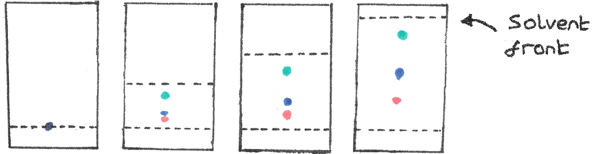
Compound G is adsorbed
(a) more strongly onto the stationary phase and has a smaller R_{f} value than component B.
(b) more strongly onto the stationary phase and has a larger R_{f} value than component B.
(c) less strongly onto the stationary phase and has a smaller R_{f} value than component B.
(d) less strongly onto the stationary phase and has a larger R_{f} value than component B.

End of Section One

Section Two: Short answer 36.25% (58 Marks)

This section has 8 questions. Answer all questions. Write your answers in the spaces provided.

When calculating numerical answers, show your working or reasoning clearly. Express numerical answers to the appropriate number of significant figures and include appropriate units where applicable.

Spare pages are included at the end of this booklet. They can be used for planning your responses and/or as additional space if required to continue an answer.
• Planning: If you use the spare pages for planning, indicate this clearly at the top of the
page.
• Continuing an answer: If you need to use the space to continue an answer, indicate in
the original answer space where the answer is continued, i.e. give the page number. Fill in the number of the question(s) that you are continuing to answer at the top of the page.

Suggested working time: 50 minutes.

Question 21 (6 marks)

(a) Write the formulae of each of the following compounds. (3 marks)

Name | Formula
Calcium hydrogen carbonate
Vanadium (IV) bromide
Phosphorus pentoxide

(b) Write the names of each of the following species. (3 marks)

Formula | Name
SO₄²⁻
Li₂O
Cu(OH)₂

Question 22 (9 marks)

Draw the Lewis structures for the following substances, showing all valence electrons. State whether each substance is polar or non-polar.

Substance | Lewis Structure | Polarity
Silicon dioxide
Carbon tetrafluoride
Nitrogen triiodide

Question 23 (11 marks)

Five unlabelled solutions are known to be; sodium sulfate, sodium iodide, sodium carbonate, sodium nitrate, barium hydroxide.

These 5 solutions are randomly labelled V, W, X, Y, Z and samples are tested with reagents. These tests are described in the table below.

 | Solutions
Reagents | V | W | X | Y | Z
Mg(NO₃)₂ | no visible reaction | no visible reaction | no visible reaction | white ppt | white ppt
Ba(NO₃)₂ | no visible reaction | no visible reaction | white ppt | white ppt | no visible reaction
Pb(NO₃)₂ | no visible reaction | yellow ppt | white ppt | white ppt | white ppt

In the space below deduce what can be inferred about the identity of the samples when each of the reagents are used.
- Mg(NO₃)₂ (3 marks)

________________________________________________________________________________________________________________________________________________________________________________________________

- Ba(NO₃)₂ (3 marks)

________________________________________________________________________________________________________________________________________________________________________________________________

- Pb(NO₃)₂ (3 marks)

________________________________________________________________________________________________________________________________________________________________________________________________

- Identify the solutions: (2 marks)

Sample | V | W | X | Y | Z
Identify of Solution:

Question 24 (4 marks)

Using a labelled diagram, show how ion-dipole forces are formed when potassium chloride dissolves in water.

Question 25 (9 marks)

The diagram below shows a Mass Spectrometry apparatus being used to analyse a sample of chlorine, which contains the isotopes chlorine-35 and chlorine-37.

Results
³⁷Cl
Injection of vapourised sample
Positively charged plates (+)
A
B
Ions
Magnetic field
C
Negatively charged plates (–)
Beam of electrons
Detector
³⁵Cl

D

85.0%
Relative Abundance

15.0%

(a) Ionisation of chlorine atoms occurs at A. Explain what is meant by the term ionisation in this situation. In your answer explain why energy is required for ionisation to occur.
(2 marks)

__________________________________________________________________________________

__________________________________________________________________________________

__________________________________________________________________________________

__________________________________________________________________________________

__________________________________________________________________________________

(b) Write the formula of the ions present at B.
(1 mark)

__________________________________________________________________________________

(c) (i) The ions of which isotope are present at C? (1 mark)

__________________________________________________________________________________

(ii) Explain you answer to part (c) (i). (2 marks)

__________________________________________________________________________________

__________________________________________________________________________________

__________________________________________________________________________________

__________________________________________________________________________________

__________________________________________________________________________________

- Use the results shown to calculate the relative atomic mass (atomic weight) of this sample of chlorine.
(2 marks)

__________________________________________________________________________________

__________________________________________________________________________________

__________________________________________________________________________________

- Explain why this sample is probably not naturally occurring chlorine.
(1 mark)

__________________________________________________________________________________

__________________________________________________________________________________

Question 26 (5 marks)

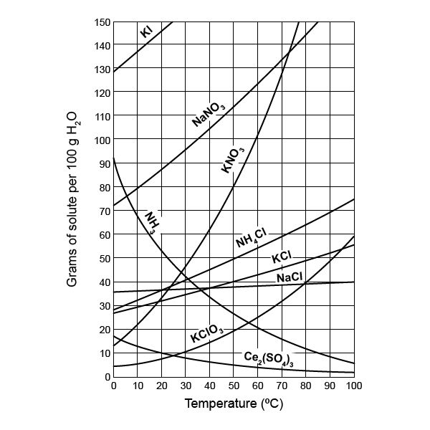

(a) Use the graph above to estimate the solubility of: (2 marks)
(i) Potassium nitrate at 55 ºC.
__________________________________________________________________________________
(ii) Ammonia at 70 ºC.
__________________________________________________________________________________

(b) If a solution of potassium nitrate is described as 5.5 g L⁻¹, calculate the concentration in mol L⁻¹. (1 mark)
__________________________________________________________________________________
__________________________________________________________________________________
__________________________________________________________________________________

(c) Explain the difference between the terms saturated and unsaturated, with reference to the data for a solution of sodium nitrate at 30 ºC. (2 marks)

__________________________________________________________________________________
__________________________________________________________________________________
__________________________________________________________________________________

Question 27 (5 marks)
Consider the information about some pure substances.

Substance | Melting point (ºC) | Boiling point  (ºC) | Electrical conductivity in solid state | Electrical conductivity in liquid state | Solubility in water
1 | 1535 | 2750 | good | good | insoluble
2 | 800 | 1410 | non | good | soluble
3 | -259 | -253 | non | non | insoluble
4 | 1710 | 2590 | non | non | insoluble
5 | 50 | 265 | non | non | insoluble

- Which one of the substances above is most likely a gas at room temperature?
(1 mark)
__________________________________________________________________________________________
(b) Which one of the substances above is most likely to be a covalent molecular solid? (1 mark)
__________________________________________________________________________________________

(c) Which one of the substances above is most likely to be a metal? (1 mark)
__________________________________________________________________________________________

(d) Which one of the substances above is most likely a covalent network substance? (1 mark)
__________________________________________________________________________________________

(e) Which one of the substances above is most likely an ionic substance? (1 mark)
__________________________________________________________________________________________

Question 28 (9 marks)

Write ionic equations including state symbols the following equations, and describe the observations you would expect to see for each reaction.

(a) Barium nitrate solution is mixed with iron(II) sulfate solution.
Ionic Equation: (2 marks)
Observations: (1 mark)

__________________________________________________________________________________________
__________________________________________________________________________________________
__________________________________________________________________________________________
(b) Lead(II) nitrate solution is mixed with magnesium iodide solution.
Ionic Equation: (2 marks)
Observations: (1 mark)

__________________________________________________________________________________________
__________________________________________________________________________________________
__________________________________________________________________________________________

(c) Sodium sulfide solution is mixed with silver nitrate solution.
Ionic Equation: (2 marks)
Observations: (1 mark)

__________________________________________________________________________________________
__________________________________________________________________________________________
__________________________________________________________________________________________

End of Section Two
Section Three: Extended answer 38.75% (62 Marks)

This section contains 6 questions. You must answer all questions. Write your answers in the spaces provided.

Where questions require an explanation and/or description, marks are awarded for the relevant chemical content and also for coherence and clarity of expression. Lists or dot points are unlikely to gain full marks.

Final answers to calculations should be expressed to the appropriate number of significant figures.

Spare pages are included at the end of this booklet. They can be used for planning your responses and/or as additional space if required to continue an answer.
• Planning: If you use the spare pages for planning, indicate this clearly at the top of the
page.
• Continuing an answer: If you need to use the space to continue an answer, indicate in the original answer space where the answer is continued, i.e. give the page number. Fill in the number of the question(s) that you are continuing to answer at the top of the page.

Suggested working time: 60 minutes.

Question 29 (7 marks)

The approximate boiling points of the Group 14, 15, 16 and 17 hydrides are plotted on the graph below.
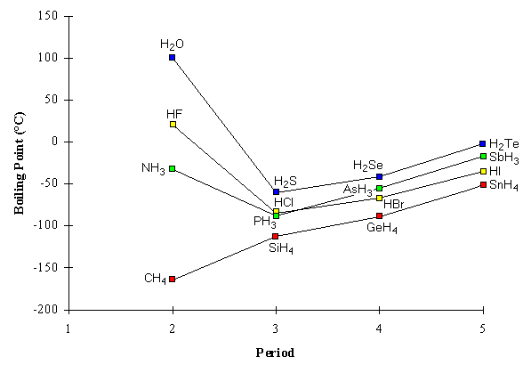

  - The hydrides of Group 14 are non-polar molecules. Apply your understanding of intermolecular interactions to explain the steadily increasing boiling points of the Group 14 hydrides CH₄, SiH₄, GeH₄ and SnH₄.
(2 marks)
____________________________________________________________________________________________________________________________________________________________________________________________________________________________________________________________________________

- The Group 15, 16 and 17 hydrides are polar molecules. Consider the Group 17 hydrides HCl, HBr and HI. List HCl, HBr and HI in order of increasing polarity.
(1 mark)

___________________________________________________________________

- Compare the trend in polarities of HCl, HBr and HI with the observed trend in their boiling points. Briefly explain your reasoning.
(2 marks)
____________________________________________________________________________________________________________________________________________________________________________________________________________________________________________________________________________

- The first member of each hydride series (NH₃ in Group 15, H₂O in Group 16, and HF in Group 17) has a much higher boiling point than the next hydride in its series. Apply your understanding of intermolecular interactions to explain the anomalous boiling points of NH₃, H₂O and HF.
(2 marks)
_______________________________________________________________________________________________________________________________________________________________________________________________________________________________________________________________________________________________________________________________________________

Question 30 (12 marks)

Diamond and graphite are two allotropes of carbon with distinctly different covalent network structures and physical properties. Compare them in terms of the following points.
(a) Compare the covalent network structures of both diamond and graphite, using a diagram if you wish. (4 marks)

__________________________________________________________________________________________
__________________________________________________________________________________________
__________________________________________________________________________________________
__________________________________________________________________________________________
__________________________________________________________________________________________
__________________________________________________________________________________________

(b) Electrical conductivity.

(i) Explain why diamond does not conduct electricity. (2 marks)

_________________________________________________________________________________________

_________________________________________________________________________________________

_________________________________________________________________________________________

_________________________________________________________________________________________

(ii) Explain why graphite does conduct electricity. (2 marks)

__________________________________________________________________________________________
__________________________________________________________________________________________
__________________________________________________________________________________________
__________________________________________________________________________________________

(c) Hardness of the solid.

(i) Explain why diamond is so hard. (2 marks)
_________________________________________________________________________________________

_________________________________________________________________________________________

_________________________________________________________________________________________

_________________________________________________________________________________________

(ii) Explain why graphite is soft. (2 marks)

__________________________________________________________________________________________
__________________________________________________________________________________________
__________________________________________________________________________________________
__________________________________________________________________________________________

Question 31 (5 marks)

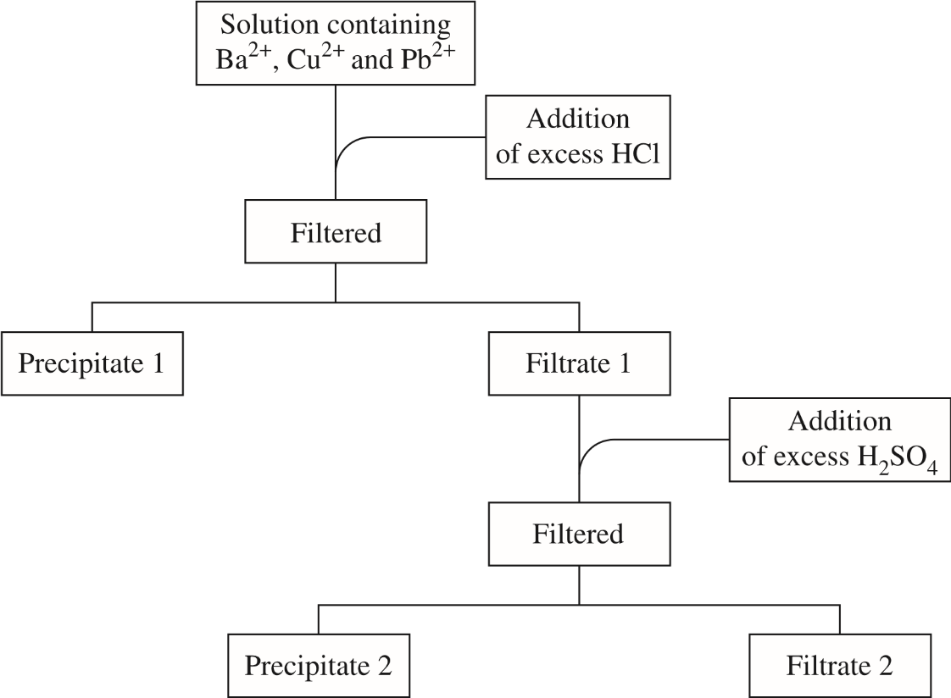
A solution contains three cations, Ba²⁺, Cu²⁺ and Pb²⁺. The flow chart indicates the plan used to confirm the identity of these cations.
Addition of excess NaOH

- Name Precipitate 2
(1 mark)
____________________________________________________________________________________

- Write a balanced equation for the formation of Precipitate 1
(2 marks)

____________________________________________________________________________________

- Suggest a test and the expected result that would confirm the identity of the metal cation remaining in Filtrate 2.
(2 marks)
____________________________________________________________________________________
____________________________________________________________________________________
____________________________________________________________________________________
____________________________________________________________________________________

This page has been left blank intentionally

Question 32 (17 marks)

(a) What was Niels Bohr’s contribution to the understanding of atomic structure?
(2 marks)
_________________________________________________________________________________________
_________________________________________________________________________________________
_________________________________________________________________________________________
_________________________________________________________________________________________

(b) How does his contribution contribute to our understanding of analytical techniques such as Flame tests? (3 marks)

_________________________________________________________________________________________

_________________________________________________________________________________________

_________________________________________________________________________________________

_________________________________________________________________________________________
_________________________________________________________________________________________
_________________________________________________________________________________________
_________________________________________________________________________________________
(c) A drinking water sample was thought to be contaminated with lead(II) ions. The absorbance readings, on an Atomic Absorption Spectrometer, of some known samples of lead(II) ions are shown below. Draw a graph showing the relationship between lead(II) ion concentration and the absorbance level. (5 marks)

Concentration of lead(II) ions (mg L⁻¹) | Absorbance
0.0010 | 10
0.0030 | 35
0.0070 | 70
0.010 | 95
0.013 | 125
0.016 | 160
0.020 | 195

Note: A spare grid is provided at the end of the examination if required

- The suspect drinking water sample was then tested on the same Atomic Absorption Spectrometer and the absorbance measured at 105. Find the concentration of lead(II) ions, and use this to determine if the water is safe to drink. Briefly show your reasoning on the graph itself or in the space below.

(The maximum acceptable level of lead in drinking water has been established by t National Health and Medical Research Centre at 0.01 mg L⁻¹)
(2 marks)
Source: https://www.nhmrc.gov.au/guidelines-publications/eh52
_________________________________________________________________________________________

_________________________________________________________________________________________

_________________________________________________________________________________________
(e) An alternative way to monitor the concentration of contaminants in drinking water is using a precipitation reaction. Barium ions are harmful to health, and the National Health and Medical Research Centre state that they should not be present at a concentration greater than 2 parts per million. A sample of drinking water can be tested for barium ions by adding potassium sulfate solution.

Write an ionic equation for the precipitation reaction that takes place. (1 mark)

_________________________________________________________________________

(f) A 2.00 kg sample of drinking water is tested for barium ions by the addition of 100 mL of 1.00 mol L⁻¹ potassium sulfate solution. The mixture is stirred until no more precipitate forms, and the water is evaporated, until only a white solid remains. The mass of solid produced is 5.73 mg.
Assuming all of the white solid is barium sulfate, calculate the concentration of barium in the water sample in parts per million, and determine whether the barium level poses a risk to health.

Note: Your answer MUST be to the correct number of significant figures
(4 marks)

_________________________________________________________________________________________

_________________________________________________________________________________________

_________________________________________________________________________________________

_________________________________________________________________________________________

_________________________________________________________________________________________

_________________________________________________________________________________________

_________________________________________________________________________________________

_________________________________________________________________________________________

_________________________________________________________________________________________

_________________________________________________________________________________________

_________________________________________________________________________________________

_________________________________________________________________________________________

_________________________________________________________________________________________

_________________________________________________________________________________________

_________________________________________________________________________________________

This page has been left blank intentionally

Question 33 (7 marks)

Barium hydroxide is used as an additive in thermoplastics (such as PVC) to improve the plastic properties relating to hardness – ie to resist scratching. It also finds applications when used as a general-purpose additive for lubricants and greases to improve their performance especially in high temperature applications such as motor racing.

Barium hydroxide is a white crystalline solid that has a melting point 407 ºC when in the anhydrous form.
Barium hydroxide can be prepared by dissolving Barium oxide (BaO) in water:
BaO + x H₂O → Ba(OH)₂ . xH₂O

To determine the water of hydration and the molecular formula for a sample of Barium hydroxide was placed in a clean and dry porcelain crucible and lid before placed in an oven set at 250ºC. The after heating for 15 minutes the crucible with lid on was allowed to cool and weighed. This heating, cooling, weighing procedure was repeated on the same sample until it reached a constant weight.

The analyst’s results are below:

Mass of empty crucible and lid | 16.28g
Initial mass of crucible, lid and sample | 17.72g
Mass after first heating/cooling | 17.19g
Mass after second heating/cooling | 17.07g
Mass after third heating/cooling | 16.95g
Mass after fourth heating/cooling | 16.95g
Mass after fifth heating/cooling | 16.96g

(a) Determine the number of moles of water that was in the hydrated lattice structure.
(2 marks)
__________________________________________________________________________________________
__________________________________________________________________________________________
__________________________________________________________________________________________
__________________________________________________________________________________________
__________________________________________________________________________________________
__________________________________________________________________________________________

(b) Determine the molecular formula for the barium hydroxide sample.
(3 marks)

__________________________________________________________________________________________
__________________________________________________________________________________________
__________________________________________________________________________________________
__________________________________________________________________________________________
__________________________________________________________________________________________
__________________________________________________________________________________________

(c) Suggest a source of error and how it may affect the results.
(2 marks)

__________________________________________________________________________________________
__________________________________________________________________________________________
__________________________________________________________________________________________
__________________________________________________________________________________________
__________________________________________________________________________________________
__________________________________________________________________________________________
__________________________________________________________________________________________
__________________________________________________________________________________________

Question 34 (14 marks)

A chewable tablet that is used to treat indigestion has a claim on the label that each tablet contains:

“250mg of sodium alginate, 133.5mg of sodium bicarbonate, 80 mg of calcium carbonate as the active ingredients and xylitol, mannitol (E421), polyethylene glycol, aspartame (E951, magnesium stearate, peppermint flavour and colouring (E132).”

(a) Calculate the amount, in moles, of calcium carbonate and sodium hydrogen carbonate (also known as “sodium bicarbonate”) in one tablet.

(4 marks)
__________________________________________________________________________________________
__________________________________________________________________________________________
__________________________________________________________________________________________
__________________________________________________________________________________________
__________________________________________________________________________________________
(b) Determine the number of moles of calcium ions in one tablet.
.
(2 marks)
__________________________________________________________________________________________
__________________________________________________________________________________________
__________________________________________________________________________________________
__________________________________________________________________________________________
__________________________________________________________________________________________

(c) It was also displayed on the box that:

“Each four tablet dose contains 10.6 mmol of sodium and 3.2 mmol of calcium. If you have been advised a diet restricted of any of these please consult your doctor before taking this product”.

Show how the figure of 3.2 mmol of calcium was calculated from 80 mg of calcium carbonate in each tablet.

(3 marks)
__________________________________________________________________________________________
__________________________________________________________________________________________
__________________________________________________________________________________________
__________________________________________________________________________________________
__________________________________________________________________________________________

(d) Sodium alginate is an extract from seaweed. It is composed of a long chain of molecules similar to carbohydrate chains. The formula for sodium alginate can be represented as (C₆H₇NaO₆)_{n}. Where n is a very large number.

From the information that four tablets contain 10.6 mmol of sodium ions and assuming that sodium alginate and sodium hydrogen carbonate are the only substances in the tablets that contain sodium, calculate the mass of sodium (as sodium ions) present in the sodium alginate for a four tablet dose.

(5 marks)
__________________________________________________________________________________________
__________________________________________________________________________________________
__________________________________________________________________________________________
__________________________________________________________________________________________
__________________________________________________________________________________________
__________________________________________________________________________________________
__________________________________________________________________________________________
__________________________________________________________________________________________
__________________________________________________________________________________________
__________________________________________________________________________________________

End of questions

Additional Working Space

__________________________________________________________________________________________

__________________________________________________________________________________________

__________________________________________________________________________________________

__________________________________________________________________________________________

__________________________________________________________________________________________

__________________________________________________________________________________________

__________________________________________________________________________________________

__________________________________________________________________________________________

__________________________________________________________________________________________

__________________________________________________________________________________________

__________________________________________________________________________________________

__________________________________________________________________________________________

__________________________________________________________________________________________

__________________________________________________________________________________________

__________________________________________________________________________________________

__________________________________________________________________________________________

__________________________________________________________________________________________

__________________________________________________________________________________________

__________________________________________________________________________________________

__________________________________________________________________________________________

__________________________________________________________________________________________

__________________________________________________________________________________________

__________________________________________________________________________________________

__________________________________________________________________________________________

__________________________________________________________________________________________

__________________________________________________________________________________________

__________________________________________________________________________________________

__________________________________________________________________________________________

__________________________________________________________________________________________

Spare grid for Question 32

__________________________________________________________________________________________

__________________________________________________________________________________________

__________________________________________________________________________________________

__________________________________________________________________________________________

__________________________________________________________________________________________

__________________________________________________________________________________________

__________________________________________________________________________________________

__________________________________________________________________________________________

__________________________________________________________________________________________

__________________________________________________________________________________________

__________________________________________________________________________________________

__________________________________________________________________________________________

__________________________________________________________________________________________

__________________________________________________________________________________________

__________________________________________________________________________________________

__________________________________________________________________________________________

__________________________________________________________________________________________

__________________________________________________________________________________________

__________________________________________________________________________________________

__________________________________________________________________________________________

__________________________________________________________________________________________

__________________________________________________________________________________________

__________________________________________________________________________________________

__________________________________________________________________________________________

__________________________________________________________________________________________

__________________________________________________________________________________________

__________________________________________________________________________________________

__________________________________________________________________________________________

__________________________________________________________________________________________

__________________________________________________________________________________________

__________________________________________________________________________________________

__________________________________________________________________________________________

__________________________________________________________________________________________

__________________________________________________________________________________________

__________________________________________________________________________________________

__________________________________________________________________________________________

__________________________________________________________________________________________

__________________________________________________________________________________________

__________________________________________________________________________________________

__________________________________________________________________________________________

__________________________________________________________________________________________

__________________________________________________________________________________________

